**AIML with MERN Project Documentation**

**Smart Sorting: Transfer Learning for Identifying Rotten Fruits and Vegetables**

**1. Introduction**

**Project Title:**  
Smart Sorting: Transfer Learning for Identifying Rotten Fruits and Vegetables

**Team Members:**

1. A. Jyothendra Sai Ram
2. B. Bindu Bhargavi
3. B. Siddhardha Bheem
4. B. Himanth

**2. Project Overview**

**Purpose:**  
To develop a system that automatically detects and classifies rotten fruits and vegetables using transfer learning techniques. The goal is to reduce food waste and improve quality control.

**Features:**

* Image-based detection using deep learning
* Real-time prediction and feedback
* User authentication and prediction history
* Responsive web interface
* Dashboard visualization for analysis

**3. Architecture**

**Frontend:**  
Built using React.js. It includes components for image upload, result display, and dashboard analytics. Axios is used for API requests. Tailwind CSS handles UI styling.

**Backend:**  
Developed using Node.js and Express.js. It handles API routing, image processing, and connects with the ML model and MongoDB.

**Database:**  
MongoDB stores user data, prediction logs, and image metadata. Mongoose is used to define schemas and interact with the database.

**4. Setup Instructions**

**Prerequisites:**

* Node.js
* MongoDB
* React
* Express
* Mongoose
* Python (for ML model if applicable)

**Installation Steps:**

1. Clone the repository
2. Navigate to the root directory
3. Run npm install in both client/ and server/ directories
4. Create a .env file with MongoDB URI and server port
5. Start the backend and frontend servers

**5. Folder Structure**

**Client (React Frontend):**

* components/ – Reusable UI components
* pages/ – Page-level React components
* services/ – API service files
* assets/ – Static files and images

**Server (Node.js Backend):**

* routes/ – Defines API endpoints
* controllers/ – Contains business logic
* models/ – Mongoose schemas
* server.js – Entry point

**6. Running the Application**

* **Frontend:**  
  Run npm start in the client/ directory
* **Backend:**  
  Run npm start in the server/ directory

**7. API Documentation**

* POST /api/predict
  + **Description:** Uploads an image and returns prediction
  + **Request Body:** FormData (image file)
  + **Response:** { label: "rotten", confidence: 0.93 }
* POST /api/login
  + **Description:** Authenticates user and returns JWT
* GET /api/history
  + **Description:** Retrieves prediction history for authenticated user

**8. Authentication**

* Uses **JWT (JSON Web Token)** for secure user authentication
* Tokens are issued during login and required for accessing protected routes
* Passwords are securely stored using hashing (e.g., bcrypt)

**9. User Interface**

* Clean, responsive design using Tailwind CSS
* Image upload interface
* Real-time result display
* Dashboard with prediction history and statistics

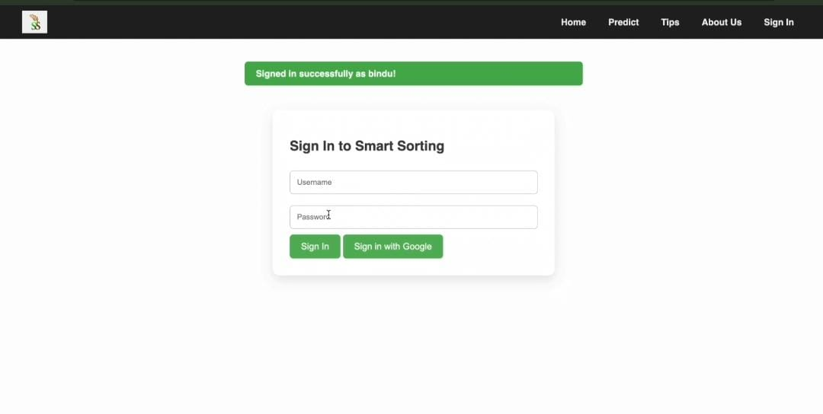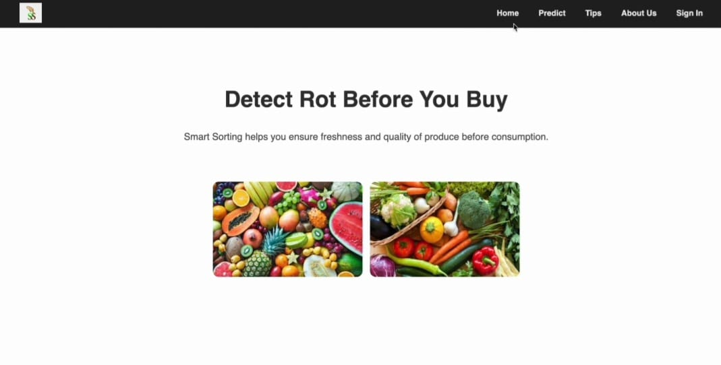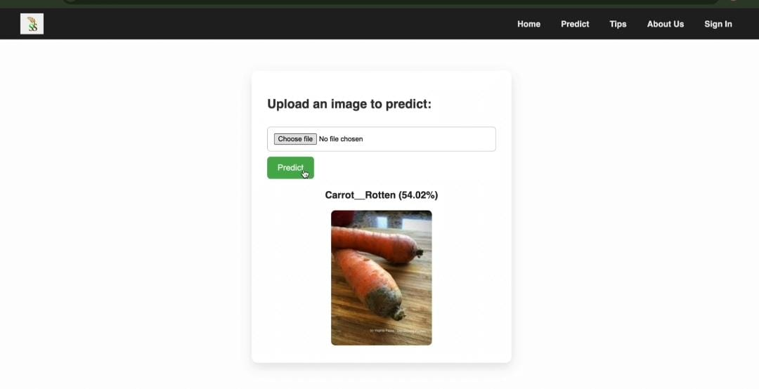

**10. Testing**

* **Frontend Testing:**  
  Unit tests written with **Jest**
* **Backend Testing:**  
  API tests performed using **Mocha**  
  Manual API testing done via **Postman**

**11. Known Issues**

* Model may misclassify images under poor lighting conditions
* Large image files can delay predictions
* Currently, no multi-language support

**12. Future Enhancements**

* Improve model accuracy with more diverse training data
* Develop a mobile app version
* Add multi-language interface support
* Integrate with real-time smart sorting hardware